N-Queens Worksheet

Search in the Incremental Space
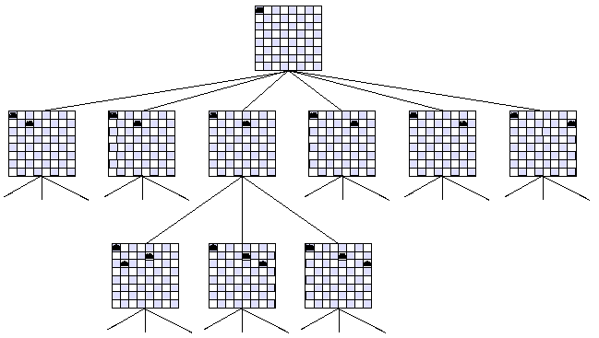

Incremental State
(defmethod actions ((problem nqueens-incremental-problem) state)
"Generate the possible moves from an nqueens-incremental state.
A move is simply the row position of the queen in the next column."
(let ((n (length state))
(next-col (position nil state))
(actions nil))
;;; For each possible square, check if attacked by previously placed queens
(loop for row from 0 to (1- n) do
(unless (some #'(lambda (col)
(let ((q (elt state col)))
(or (= q row) (= (- next-col col) (abs (- q row))))))
(iota next-col))
(push row actions)))
actions))

Complete State
(defmethod actions ((problem nqueens-complete-problem) state)
"Generate the possible moves from a complete nqueens state.
A move is simply the column and the new row for that queen."
(let ((n (length state))
(actions nil))
;;; For each column, generate all other rows but the current one
(loop for col from 0 to (1- n) do
(let ((q (elt state col)))
(loop for row from 0 to (1- n) do
(unless (= row q) (push (list col row) actions)))))
actions))

(defmethod h-cost ((problem nqueens-complete-problem) state)
"Number of pairs of queens attacking each other."
(let ((n (length state))
(sum 0))
(loop for i from 0 to (- n 2) do
(loop for j from (1+ i) to (- n 1) do
(let ((delta (- (aref state i) (aref state j))))
(when (or (= delta 0) (= (abs delta) (- j i)))
(incf sum)))))
sum))
How Common are the N-queens solutions? The following table came from http://www.durangobill.com/N_Queens.html and shows the number of solutions (and unique solutions) along with their probabilities. These probabilities are “inflated” in that I assumed the queens each had to be in separate rows or columns (N! such configurations) whereas, there are far more dumb solutions (N² choose N ~ O(N^{2N})).

Order ("N") | Ordinary Queens Total Solutions | Ordinary Queens Unique Solutions | Probability of | Probability of
Order ("N") | Ordinary Queens Total Solutions | Ordinary Queens Unique Solutions | Total Solutions | Unique Solutions
1 | 1 | 1 | 1 | 1
2 | 0 | 0 | 0 | 0
3 | 0 | 0 | 0 | 0
4 | 2 | 1 | 0.083333333 | 0.041666667
5 | 10 | 2 | 0.083333333 | 0.016666667
6 | 4 | 1 | 0.005555556 | 0.001388889
7 | 40 | 6 | 0.007936508 | 0.001190476
8 | 92 | 12 | 0.002281746 | 0.000297619
9 | 352 | 46 | 0.000970018 | 0.000126764
10 | 724 | 92 | 0.000199515 | 2.53527E-05
11 | 2,680 | 341 | 6.71397E-05 | 8.54277E-06
12 | 14,200 | 1,787 | 2.9645E-05 | 3.73068E-06
13 | 73,712 | 9,233 | 1.18374E-05 | 1.48273E-06
14 | 365,596 | 45,752 | 4.19366E-06 | 5.2481E-07
15 | 2,279,184 | 285,053 | 1.74293E-06 | 2.17985E-07
16 | 14,772,512 | 1,846,955 | 7.06049E-07 | 8.82748E-08
17 | 95,815,104 | 11,977,939 | 2.6938E-07 | 3.36755E-08
18 | 666,090,624 | 83,263,591 | 1.04038E-07 | 1.30051E-08

Image taken from http://maven.smith.edu/~thiebaut/transputer/chapter9/chap9-4.html

